Peptic ulcers are holes or breaks in the protective lining of the duodenum (the upper part of the small intestine) or the stomach -- areas that come into contact with stomach acids and enzymes.
Duodenal ulcers are more common than stomach ulcers.
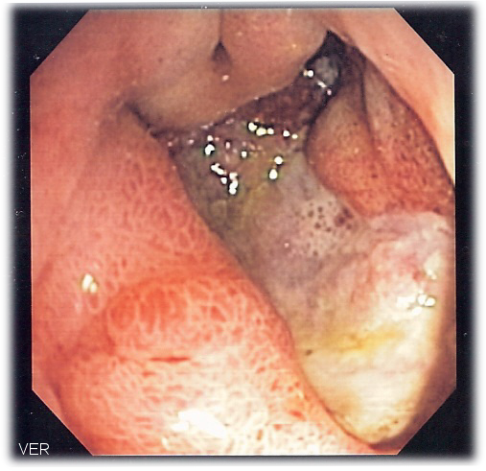
Comparatively rare are esophageal ulcers, which form in the esophagus –
or swallowing tube -- and are often a result of alcohol abuse.
Until the mid-1980s, the conventional wisdom was that ulcers form as a result
of stress, a genetic predisposition to excessive stomach acid secretion,
and poor lifestyle habits (including overindulging in rich and fatty foods,
alcohol, caffeine, and tobacco).
It was believed that such influences contribute to a buildup of stomach
acids that erode the protective lining of the stomach, duodenum, or
esophagus.

While excessive stomach acid secretion certainly plays a role in the development
of ulcers, a relatively recent theory holds that bacterial infection is the primary cause
of peptic ulcers. Indeed, research conducted since the mid-1980s has persuasively demonstrated that the bacterium Helicobacter pylori (H. pylori) is present in more than 90% of duodenal ulcers and about 80% of stomach ulcers.

