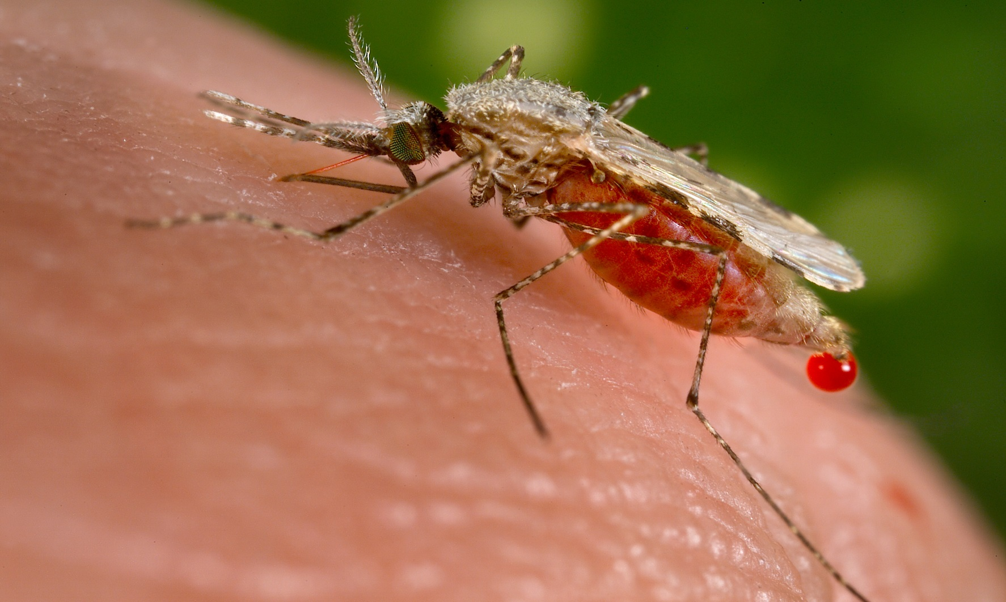

More than 40 percent of the world’s population lives in areas where there is a risk of contracting malaria.

A child dies of malaria every 30 seconds.

Nearly one million people die of malaria every year, mostly infants, young children, and pregnant women and most of them in Africa.

Approximately 300 to 500 million cases of clinical malaria occur each year.

Malaria accounts for at least $12 billion in economic losses each year in Africa, and a reduction in annual economic growth estimated at 1.3 percent.

**MALARIA**