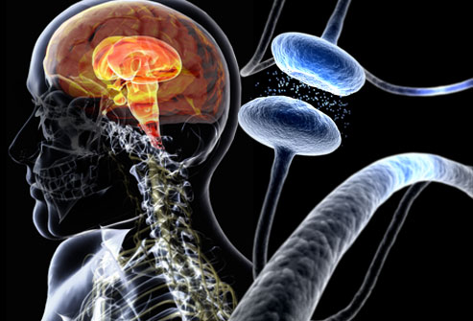

Parkinson’s disease is named after Dr James Parkinson (1755-1824), the doctor that first identified the condition.

It is caused by the loss of brain cells (neurones) in a part of the brain called the substantia nigra, which produces the chemical messenger dopamine.

As the cells die, less dopamine is produced and transported to the striatum, the area of the brain that co-ordinates movement. Symptoms develop when about 80% of dopamine has been lost.

The reason that Parkinson’s disease develops is not known.

**PARKINSON DISEASE**